**Savory Symphony – Static Restaurant Menu Page**

**Submitted By**:

* + Team Members- Vora Chanchal

Jana Samyutha M H

Brunda

* + Roll Number 2461037

2461012

2461006

* + College-E-mailid: [vora.chanchal@btech.christuniversity.in](mailto:vora.chanchal@btech.christuniversity.in)

[jana.samyutha@btech.christuniversity.in](mailto:jana.samyutha@btech.christuniversity.in)

brunda@btech.christuniversity.in

* **Course**: FrontEnd UI/UX
* **Instructor Name: Mr. Dhiraj**
* **Institution**: Christ University
* **Date of Submission**: 10/08/2025

**2. Abstract:**

**Savory Symphony** is a beautifully crafted static restaurant menu webpage designed entirely with HTML and CSS. The goal was to create an intuitive, visually appetizing interface that feels like browsing a real restaurant menu. Using CSS Grid, the layout is neatly organized into categories, making it easy for users to explore different dishes. Custom-styled filters allow users to sort by dietary preferences, and smooth hover effects reveal extra details like ingredients and spice levels—adding a touch of interactivity without relying on JavaScript.

Color psychology plays a key role in the design, with warm, inviting tones chosen to stimulate appetite and enhance the dining vibe. High-quality food images bring authenticity and richness to the page, making each dish look as tempting as it would in person. The result is a clean, responsive, and engaging menu experience that showcases strong front-end design skills and creativity, all within the boundaries of static web development.

**3. Objectives:**

* Display categorized menu items using CSS Grid.
* Apply interactive styling with CSS-only filters and hover effects.
* Design an aesthetically appealing interface using color psychology and appetizing imagery.
* Ensure a clear visual hierarchy for dish names, prices, and categories.
* Keep the layout responsive for desktop and tablet viewing.

**4. Scope of the Project:**

* Focused purely on front-end static design (HTML + CSS only).
* No JavaScript functionality or backend integration.
* Designed for desktop and tablet viewports.
* Incorporated only open-source tools and royalty-free images.
* Core goal was to showcase CSS Grid usage, custom styling, and static interactivity.

**5. Tools & Technologies Used**

|  |  |
| --- | --- |
| Tool/Technology | Purpose |
| HTML5 | Markup and content structure |
| CSS3 | Styling and layout management |
| VS Code and Notepad | Code editor |
| Chrome DevTools | Testing and debugging |

**6. HTML Structure Overview:**

* Semantic tags used: <header>, <section>, <div>, <button>, <img>.
* Header section includes the project title and tagline.
* Filters section with category/dietary buttons.
* Menu section divided into dish cards under categories: *Starters, Mains, Desserts*.
* Each dish card contains an image, name, description, price, and tags.

**7. CSS Styling Strategy:**

* CSS Grid used for menu item layout.
* Hover ingredient reveal implemented with hidden paragraph tags displayed on hover.
* Custom button styling for filters using rounded corners and bold typography.
* Applied box-shadows and rounded corners for modern UI appeal.
* Color palette chosen to stimulate appetite (warm coral, cream, green accents).

**8. Key Features:**

|  |  |
| --- | --- |
| Feature | Description |
| Category & Dietary Filters | Static buttons styled with CSS for visual filtering cues |
| CSS Grid Layout | Responsive grid arrangement for dish cards |
| Hover Ingredient Reveal | Extra details appear when hovering over a dish |
| Chief’s Special Badge | Rotating highlight for special dish |
| Fixed Order Button | Always visible call-to-action for ordering |

**9. Challenges Faced & Solutions:**

|  |  |
| --- | --- |
| Challenge | Solution |
| Missing images due to local file paths | Replaced with publicly hosted Unsplash image URLs |
| Maintaining consistent layout | Used CSS Grid with auto-fit and minmax() for adaptability |
| Choosing appetizing colors | Applied food industry color psychology principles |

**10. Outcome:**

* Created a visually consistent, responsive, and appetizing restaurant menu webpage.
* All dish categories are neatly arranged, and hover effects enhance interactivity.
* Learned practical application of CSS Grid, color theory, and static UI design.

**11. Future Enhancements:**

* Add JavaScript functionality to make filters actually hide/show items dynamically.
* Include price range slider functionality.
* Add a cart counter animation.
* Make the design fully mobile-responsive.

**12. Sample Code:**

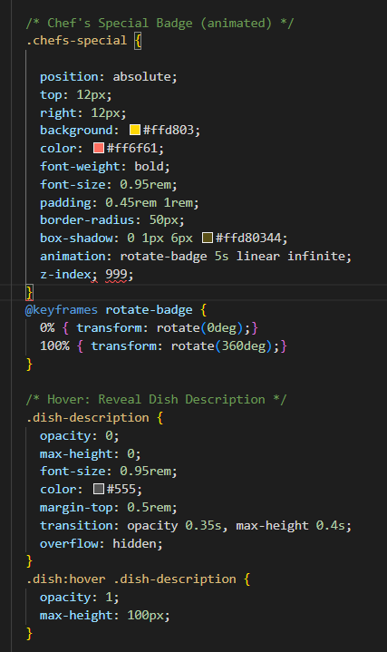 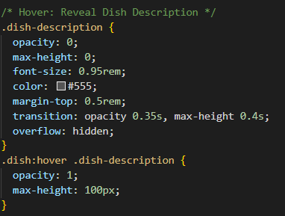 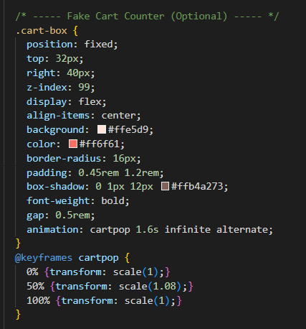

**13. Screenshots of Final Output:**

**Desktop:**

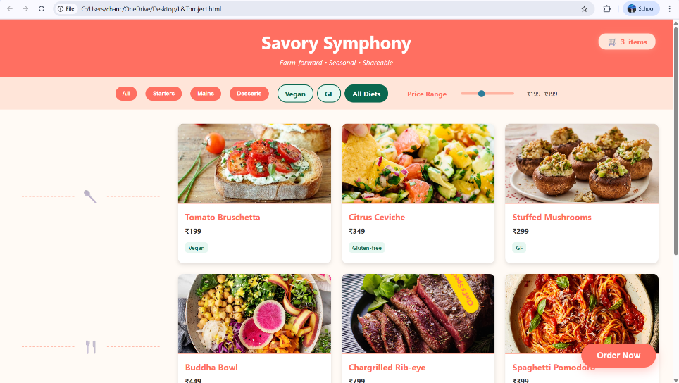 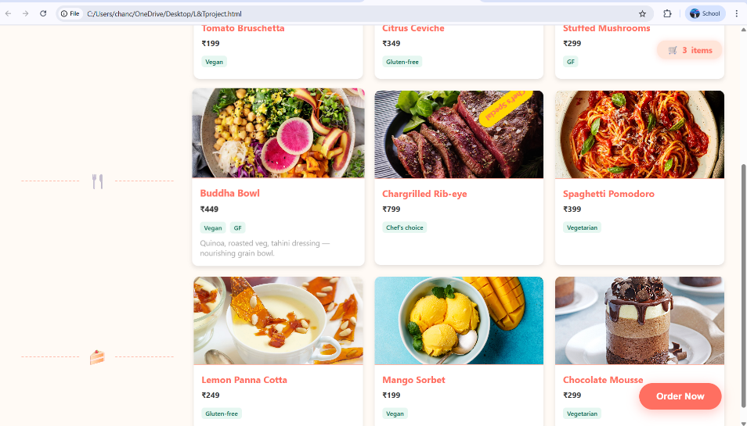

**11. Conclusion**

The **Savory Symphony** project demonstrated the ability to create an appealing, functional restaurant menu page using only HTML and CSS. The project deepened understanding of **visual hierarchy**, **grid layouts**, and **UI aesthetics**, while also reinforcing the importance of **color psychology** and **imagery** in web design. It serves as a strong example of a **CSS-only interactive design** without JavaScript.

**12. References**

* L&T LMS : <https://learn.lntedutech.com/Landing/MyCourse>
* YouTube
* W3schools <https://www.w3schools.com/html/default.asp>
* W3schools: <https://www.w3schools.com/css/default.asp>